Math 4 Name_______________________________
2-2 Practice Date________

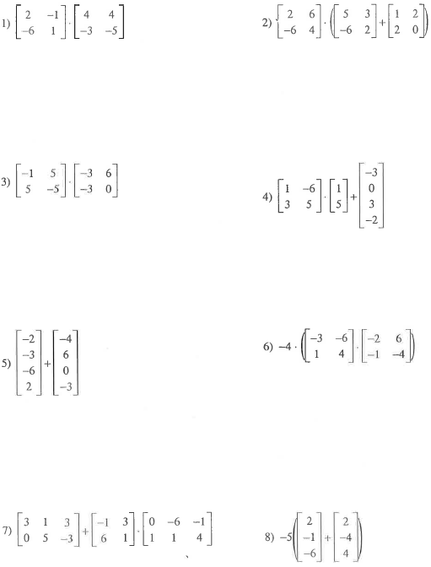
Simplify the following expressions. Write “undefined” for those that are undefined.

